Email 5/20/16 to Bruce and Ed Merkle

Hi,

I tried plotting the data by trial/bin and I’m not sure exactly this is what you meant, so I wanted to verify this while our meeting is still fresh in everyone’s memory. We talked about being able to visualize the change in the effect of race or fixation as time progresses (either trial or bin). Here I have the TBT data plotted: Trial is on the x axis, mean amplitude of the P2 is on the y, each trial for each subject and electrode is a separate data point (so you can see that there’s a lot of data points). The slope for each type of trial (Race x Fixation) is shown separately, but it’s hard to see.

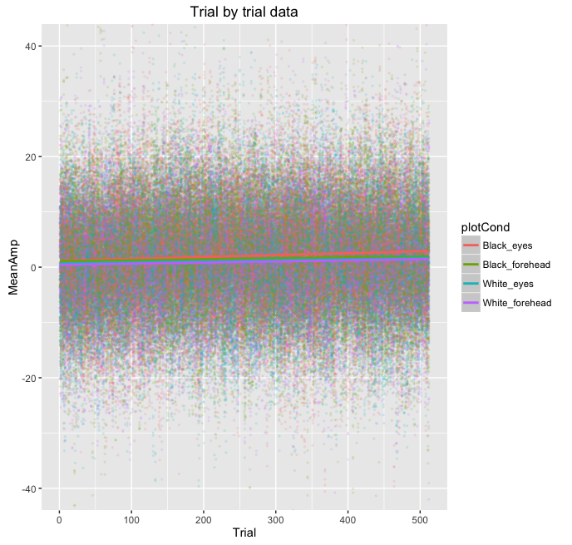

Here it is again zoomed in (restricting the range of the y axis) so it’s easier to see the slopes. There are 95% confidence intervals around those slopes by the way, they’re just so tiny that they’re hard to see.

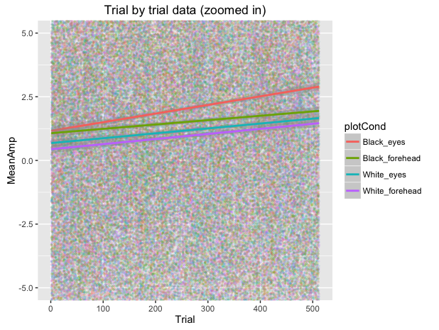

Here’s the same thing with the binned data, which shows a similar pattern, both with the full y axis and zoomed in.

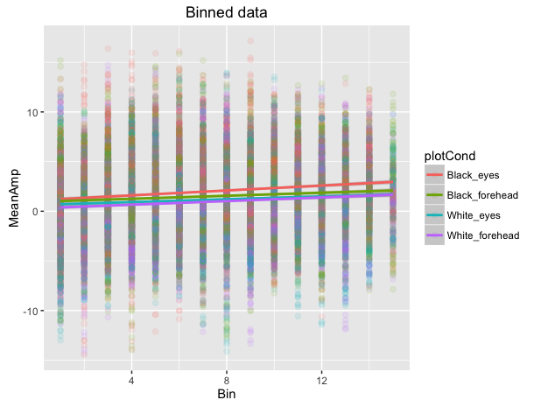

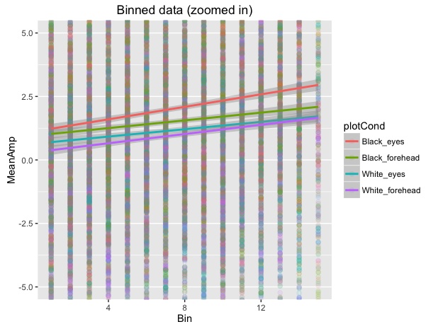

I also attached the output of the models where bin or fixation are included as a fixed effect, including all interactions. As a reminder, Trial*Race, Trial*Fix and Trial*Race*Fix are all highly significant. Same for Bin.

(see 2.6 P2_randomEffectSubject_fixedTrialWithInteractions_TBTdat.txt and 3.6 P2_randomEffectSubject_fixedBinWithInteractions_BinDat.txt)

Hannah